pubs.acs.org/NanoLett

Spontaneous Folding Growth of Graphene on h‑BN

Letter

[Xiaodong Fan,](https://pubs.acs.org/action/doSearch?field1=Contrib&text1=%22Xiaodong%2BFan%22&field2=AllField&text2&publication&accessType=allContent&Earliest&ref=pdf) [Sun-Woo Kim,](https://pubs.acs.org/action/doSearch?field1=Contrib&text1=%22Sun-Woo%2BKim%22&field2=AllField&text2&publication&accessType=allContent&Earliest&ref=pdf) [Jing Tang,](https://pubs.acs.org/action/doSearch?field1=Contrib&text1=%22Jing%2BTang%22&field2=AllField&text2&publication&accessType=allContent&Earliest&ref=pdf) [Xinjing Huang,](https://pubs.acs.org/action/doSearch?field1=Contrib&text1=%22Xinjing%2BHuang%22&field2=AllField&text2&publication&accessType=allContent&Earliest&ref=pdf) [Zhiyong Lin,](https://pubs.acs.org/action/doSearch?field1=Contrib&text1=%22Zhiyong%2BLin%22&field2=AllField&text2&publication&accessType=allContent&Earliest&ref=pdf) [Lijun Zhu,](https://pubs.acs.org/action/doSearch?field1=Contrib&text1=%22Lijun%2BZhu%22&field2=AllField&text2&publication&accessType=allContent&Earliest&ref=pdf) [Lin Li,](https://pubs.acs.org/action/doSearch?field1=Contrib&text1=%22Lin%2BLi%22&field2=AllField&text2&publication&accessType=allContent&Earliest&ref=pdf) [Jun-Hyung Cho,](https://pubs.acs.org/action/doSearch?field1=Contrib&text1=%22Jun-Hyung%2BCho%22&field2=AllField&text2&publication&accessType=allContent&Earliest&ref=pdf)* [and Changgan Zeng](https://pubs.acs.org/action/doSearch?field1=Contrib&text1=%22Changgan%2BZeng%22&field2=AllField&text2&publication&accessType=allContent&Earliest&ref=pdf)*



Cite This: *Nano Lett.* 2021, 21, 2033−2039



[Read Online](https://pubs.acs.org/doi/10.1021/acs.nanolett.0c04596?ref=pdf)

ACCESS

[Metrics & More](https://pubs.acs.org/doi/10.1021/acs.nanolett.0c04596?goto=articleMetrics&ref=pdf)

[Article Recommendations](https://pubs.acs.org/doi/10.1021/acs.nanolett.0c04596?goto=recommendations&%3Fref=pdf)

*sı [Supporting Information](https://pubs.acs.org/doi/10.1021/acs.nanolett.0c04596?goto=supporting-info&ref=pdf)

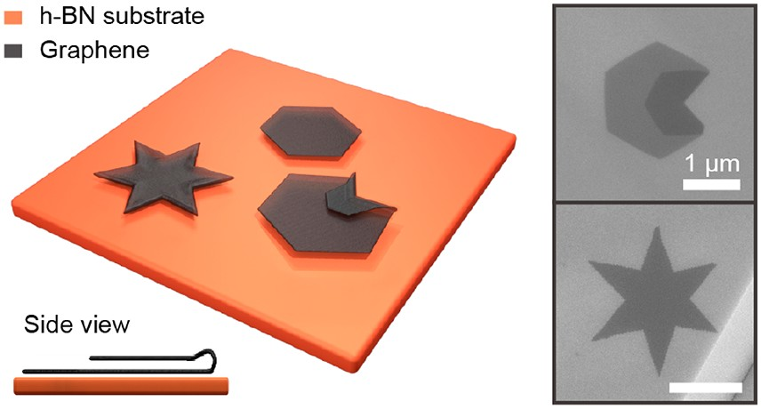

ABSTRACT: Graphene has been the subject of much research, with structural engineering frequently used to harness its various properties. In particular, the concepts of graphene origami and kirigami have inspired the design of quasi-three-dimensional graphene structures, which possess intriguing mechanical, electronic, and optical properties. However, accurate controlling the folding process remains a big challenge. Here, we report the discovery of spontaneous folding growth of graphene on the h-BN substrate via adopting a simple chemical vapor deposition method. Folded edges are formed when two stacked graphene layers share a joint edge at a growth temperature up to 1300 °C. Using *ﬁ*rst-principles density functional theory calculations, the bilayer graphene with folded edges is demonstrated to be

more stable than that with open edges. Utilizing this novel growth mode, hexagram bilayer graphene containing entirely sealed edges is eventually realized. Our *ﬁ*ndings provide a route for designing graphene devices with a new folding dimension.

KEYWORDS: *graphene, folding growth, folded edge, chemical vapor deposition*

or two-dimensional (2D) materials, structural control is an e*ﬀ*ective way to yield an extensive range of extraordinary properties.1−6 For instance, 2D materials can be easily stacked into precisely designed constructions,7 with many resulting emergent properties including Hofstadter’s butter*ﬂ*y in graphene/h-BN moirésuperlattice,8−10 superconductivity in magic-angle bilayer graphene,11,12 and moiréexcitons in transition-metal dichalcogenide heterostructures.13−15 For atomically thin layers, a new structural degree of freedom

F

has been introduced to acquire either bending or folding.1,6,16 Folding is an e*ﬀ*ective route to transfer 2D materials to functional quasi-3D forms. More importantly, this modi*ﬁ*cation allows the ability to tune their physical properties such as hydrophilia, transmittance, and mechanical properties.3,6,17 Indeed, many surprising behaviors at the edges of folded graphene have been theoretically proposed, which include spontaneous electric polarization,18 anomalous magnetism,19 snake states,20 and zero Landau level.2

To date, various approaches have been conducted to achieve edge-folded bilayer graphene (EFBG). The most common method has focused on mechanical techniques, including random folding or self-peeling during exfoliation,21,22 soni*ﬁ*ca- tion or stirring in solution,23,24 and precisely folding by

scanning probes.25,26 Besides, Joule heating and chemical modi*ﬁ*cation are also utilized to achieve folded graphene.27−32 However, some of these methods possess large randomness,

some need complicated operations, and even some will cause the quality decay of graphene sheets. Here, we use a simple chemical vapor deposition (CVD) method to demonstrate that high-quality EFBG can be spontaneously grown on the h-BN

substrate. Speci*ﬁ*cally, this method produces hexagram bilayer graphene containing entirely sealed edges in a controllable manner.

Graphene was grown on h-BN *ﬂ*akes, which were cleaved

onto SiO2/Si substrate in advance. Subsequently, acetylene (C2H2) was introduced to our CVD system as the carbon feedstock with silane (SiH4) acting as a gaseous catalyst.33 The growth temperature was maintained at 1300 °C during the whole growth period. Figure 1a shows a representative scanning electron microscope (SEM) image of the as-grown samples. Similar to previous reports,33,34 orthohexagonal monolayer graphene sheets (as indicated by the blue circles in Figure 1a) are obtained with a moirépattern emerging from the lattice mismatch between graphene and h-BN (see Figure 1a inset). Simultaneously, an unusual bilayer *ﬂ*ake appears with the segmental darker region (as indicated by the red circle in Figure 1a). This contrast arises from the formation of EFBG, as evidenced by the representative atomic force microscopy (AFM) image shown in Figure 1b. The corresponding line pro*ﬁ*le (Figure 1b) further demonstrates that the joint edge (white arrow in Figure 1b) of the two layers is protruded, which is consistent with the observations of previous studies



Received: November 19, 2020

Revised: February 19, 2021

Published: February 23, 2021

© 2021 American Chemical Society

Downloaded via UNIV OF NEW MEXICO on May 15, 2021 at 13:00:48 (UTC).

See https://pubs.acs.org/sharingguidelines for options on how to legitimately share published articles.

2033

[https://dx.doi.org/10.1021/acs.nanolett.0c04596](https://dx.doi.org/10.1021/acs.nanolett.0c04596?ref=pdf)

*Nano Lett.* 2021, 21, 2033−2039

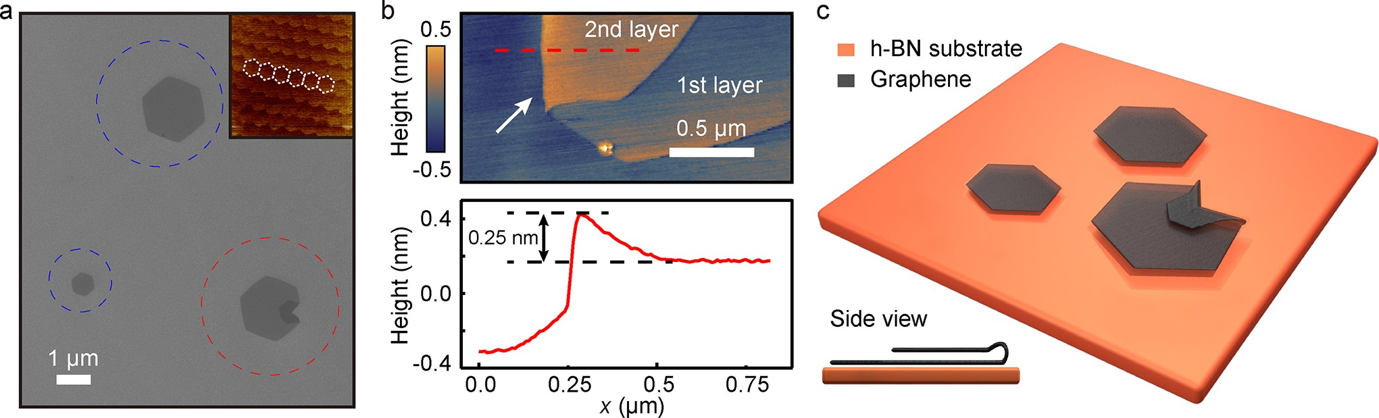

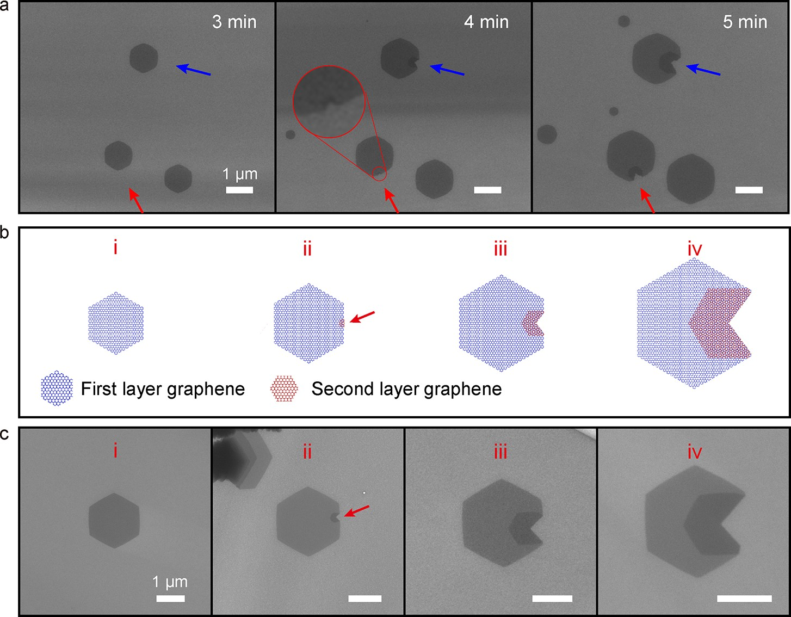Figure 1. Characterization of edge-folded bilayer graphene (EFBG). (a) Representative SEM image of the epitaxial monolayer graphene (blue circles) and EFBG (red circle) on the h-BN substrate. Inset shows the AFM friction image of the moirépattern for a graphene/h-BN heterostructure with a period of ∼14 nm. (b) Representative AFM image of the folded edge and the corresponding height line pro*ﬁ*le. (c) Schematic of monolayer graphene and EFBG on h-BN.

Figure 2. Formation process of EFBG. (a) SEM images of the continuous growth process of graphene in the same area. Blue and red arrows point to two edge-folding locations, respectively. (b) Schematics of di*ﬀ*erent growth stages of the EFBG. The growth speed ratio of the second layer to the *ﬁ*rst layer is set as 1.5. (c) SEM results corresponding to the four stages in panel b. Red arrows in panels b and c indicate the initial folding points.

about folded graphene.22,25 Figure 1c shows a schematic diagram of the monolayer graphene and EFBG grown on the h-BN substrate.

Continuous growth (as detailed in [Supplementary Note 1](http://pubs.acs.org/doi/suppl/10.1021/acs.nanolett.0c04596/suppl_file/nl0c04596_si_001.pdf)) was allowed to explore the formation process of the EFBG. Figure 2a shows the SEM images of graphene *ﬂ*akes corresponding to di*ﬀ*erent intermediate growth stages. It is clearly seen that the folding starts from a single point (see the enlarged view of the 4 min result) and is continuously extended along two directions. After the formation of the folded edges, the joint edges of the two layers stop growing while the size of the graphene bilayer still gets enlarged (see also in [Figure S1](http://pubs.acs.org/doi/suppl/10.1021/acs.nanolett.0c04596/suppl_file/nl0c04596_si_001.pdf)), indicating that the folded edges are closed.

Via measuring the domain sizes at di*ﬀ*erent growth stages shown in Figure 2a, the growth speeds of the *ﬁ*rst and second layers are estimated to be 379 nm/min and 449 nm/min, respectively. Note that the growth speed superiority of the second layer is a prerequisite for the formation of folded edge, as detailed later. Based on these experimental results, the folding process is summarized as the following stages, which are schematically drawn in Figure 2b. Initially, the folding begins to occur from a nucleated second layer at/near the edge of the *ﬁ*rst graphene layer (stage ii in Figure 2b). Then, the joint edge of the two layers is reconstructed to form a folded shape. As the growth speed of the second layer is set to be faster than that of the *ﬁ*rst layer, the edge of the second layer

continually overtakes the corresponding one of the *ﬁ*rst layer. This results in the continuous extension of the folded edges (stages iii and iv in Figure 2b). Obviously, such intermediate stages are all observed in our experimental SEM data (Figure 2c), thereby supporting our explanation for the edge-folding process. Here, we would like to address that the nucleation sites for the second graphene layer are randomly distributed on the *ﬁ*rst layer; thus, the folding could start from any position around graphene, e.g., the vertex of the *ﬁ*rst layer graphene (see [Figure S2](http://pubs.acs.org/doi/suppl/10.1021/acs.nanolett.0c04596/suppl_file/nl0c04596_si_001.pdf)).

We next investigate the mechanism of the spontaneous folding growth of graphene on h-BN using *ﬁ*rst-principles density functional theory (DFT) calculations with the inclusion of van der Waals interactions (see [Supplementary](http://pubs.acs.org/doi/suppl/10.1021/acs.nanolett.0c04596/suppl_file/nl0c04596_si_001.pdf) [Note 1](http://pubs.acs.org/doi/suppl/10.1021/acs.nanolett.0c04596/suppl_file/nl0c04596_si_001.pdf)). It has been well-known that the second layer grows underneath the *ﬁ*rst layer on the catalytic copper surface.35 By contrast, it is found that the second layer appears on top of the *ﬁ*rst layer in the present case of the noncatalytic h-BN substrate (detailed in [Supplementary Note 2](http://pubs.acs.org/doi/suppl/10.1021/acs.nanolett.0c04596/suppl_file/nl0c04596_si_001.pdf) and [Figure S3](http://pubs.acs.org/doi/suppl/10.1021/acs.nanolett.0c04596/suppl_file/nl0c04596_si_001.pdf)). The calculated adsorption energies of carbon atoms on h-BN and graphene/h-BN provide an understanding of the di*ﬀ*erent growth speeds of the *ﬁ*rst and second graphene layers. Our results show that the most stable sites of adsorbed carbon atoms on h-BN and graphene/h-BN substrates are (5) and

(15/20) (see Figure 3a−d) with the adsorption energies of 1.3

and 1.6 eV, respectively. The di*ﬀ*usion barriers of carbon atoms

on h-BN and graphene/h-BN are estimated to be 0.41 and

0.43 eV, respectively. Since the di*ﬀ*usion barriers for the two cases are nearly similar to each other, it is likely that the adsorption energy di*ﬀ*erence (∼0.3 eV) between h-BN and graphene/h-BN leads to a faster growth speed for the second graphene layer compared to the *ﬁ*rst one. Therefore, the second-layer growth overtakes the *ﬁ*rst-layer growth to form

folded edges. It is noteworthy that the resulting spontaneous folding growth of graphene uniquely occurs on the BN substrate, di*ﬀ*ering from the graphene growth on catalytic metallic substrates.36,37

We further examine the stability of folded edges. The total energy of EFBG is calculated as a function of the length *L*′ of the second graphene layer with *ﬁ*xing the length *L* = 104.6 Å of the *ﬁ*rst graphene layer (see Figure 3e). As illustrated in Figure 3f, the energy di*ﬀ*erence between EFBG and the in*ﬁ*nite monolayer graphene decreases as *L*′ increases. Interestingly, there is a critical length *L*′ around 85 Å, above which EFBG becomes thermodynamically more stable than the in*ﬁ*nite monolayer graphene. It is noted that the *ﬁ*nite monolayer graphenes are higher in energy than the in*ﬁ*nite monolayer graphene, owing to their edge energies. Considering such an edge e*ﬀ*ect in *ﬁ*nite monolayer graphenes, the critical length *L*′ would be estimated to be smaller than 85 Å in realistic conditions. We also compare the energies of EFBG and the

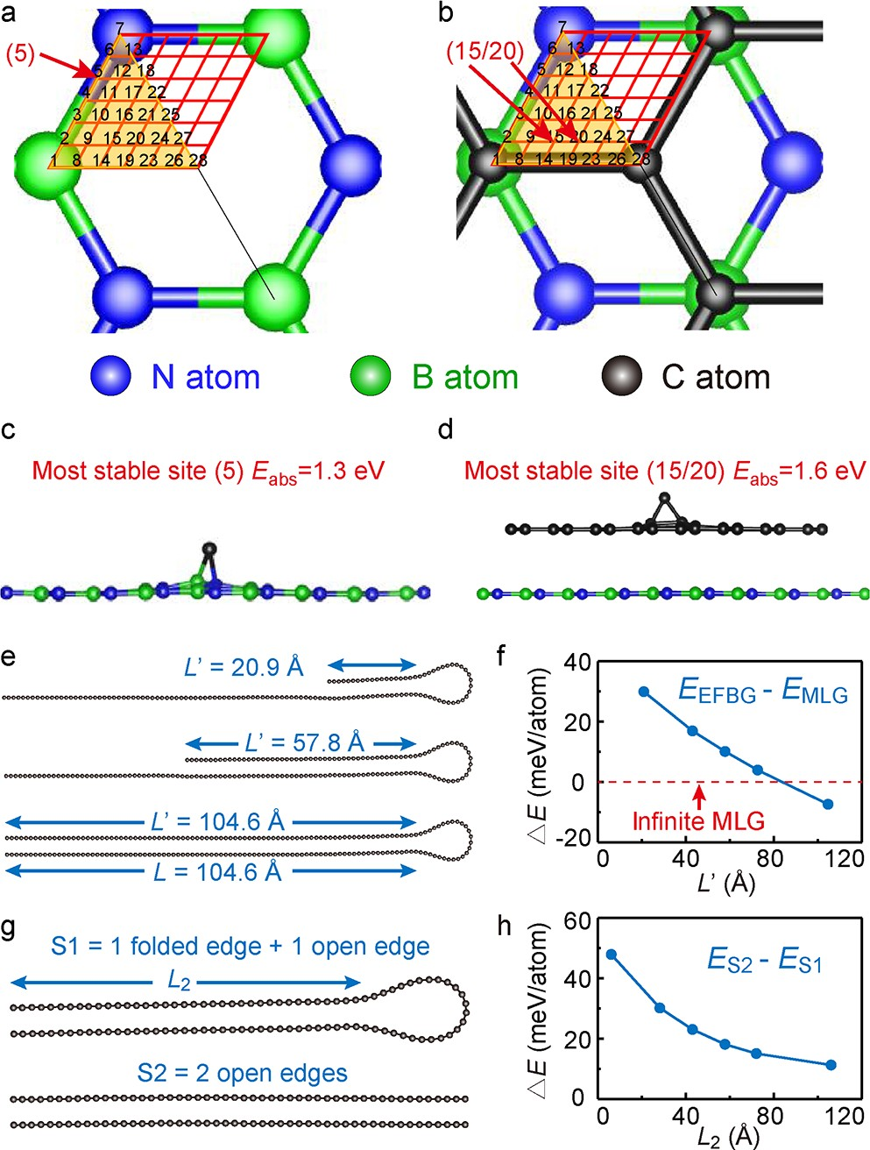

Figure 3. Calculated results. (a, c) Top and side views of the adsorption sites of C atoms on the h-BN surface. The most stable site is (5), as indicated by the red arrow. (b, d) Top and side views of the adsorption sites of C atoms on the graphene/h-BN surface. The most stable site is (15/20), as indicated by the red arrows. (e, f) Calculated formation energy of EFBG relative to the in*ﬁ*nite monolayer graphene (MLG) as a function of the length *L*′ of the second layer. (g, h) Calculated formation energy di*ﬀ*erence between bilayer graphenes with and without folded edges as a function of the length *L*2 of the bilayer graphene.

cost of more than 780 meV/atom, while the EFBG formation from bilayer graphene needs only 120 meV/atom. These values correspond to the temperatures of 8190 and 1260 K, respectively. Since our experimental growth temperature was around 1300 °C, direct bending is unlikely to occur. It is thus concluded that the observed EFBG would be formed by the reconstruction of open joint edges at our growth conditions.

Next, we consider another situation in which the second layer starts to grow around the center of the *ﬁ*rst layer. Figure 4a shows that a hexagonal domain emerges on top of the *ﬁ*rst graphene layer with a rotation angle of 30° (stage i in Figure

normal bilayer graphene with the same length *L*2 (Figure 3g).

4a). After this, the six apexes of the second layer

Due to the reduced number of dangling bonds, EFBG is always thermodynamically more stable than the bilayer graphene having open edges. As shown in Figure 3h, the energy di*ﬀ*erence between EFBG and the bilayer graphene keeps positive in the range of calculated length and seems to be converged at a large value of *L*2. On the basis of the theoretically predicted stability of folded edges, we can say that the joint edge of two layers is easily reconstructed to form a folded shape, as demonstrated in our experiments.

According to a previous theoretical work,38 the direct bending from monolayer graphene to EFBG requires an energy

simultaneously catch up on the edges of the *ﬁ*rst layer (stage ii in Figure 4a). According to our DFT total-energy calculations, the closed edge is more stable than the open edge, leading us to believe that folded edges could be spontaneously formed to lower the involved energy. As the second-layer edges continually overtake the *ﬁ*rst-layer edges, 12 folded edges are extended outward from the six folding start points (stages iii and iv in Figure 4a). Finally, the folded edges intersect each other, forming a hexagram shape with all edges entirely sealed (stage v in Figure 4a, see also [Figure S4](http://pubs.acs.org/doi/suppl/10.1021/acs.nanolett.0c04596/suppl_file/nl0c04596_si_001.pdf)). Surprisingly, we observed all intermediate stages presented in

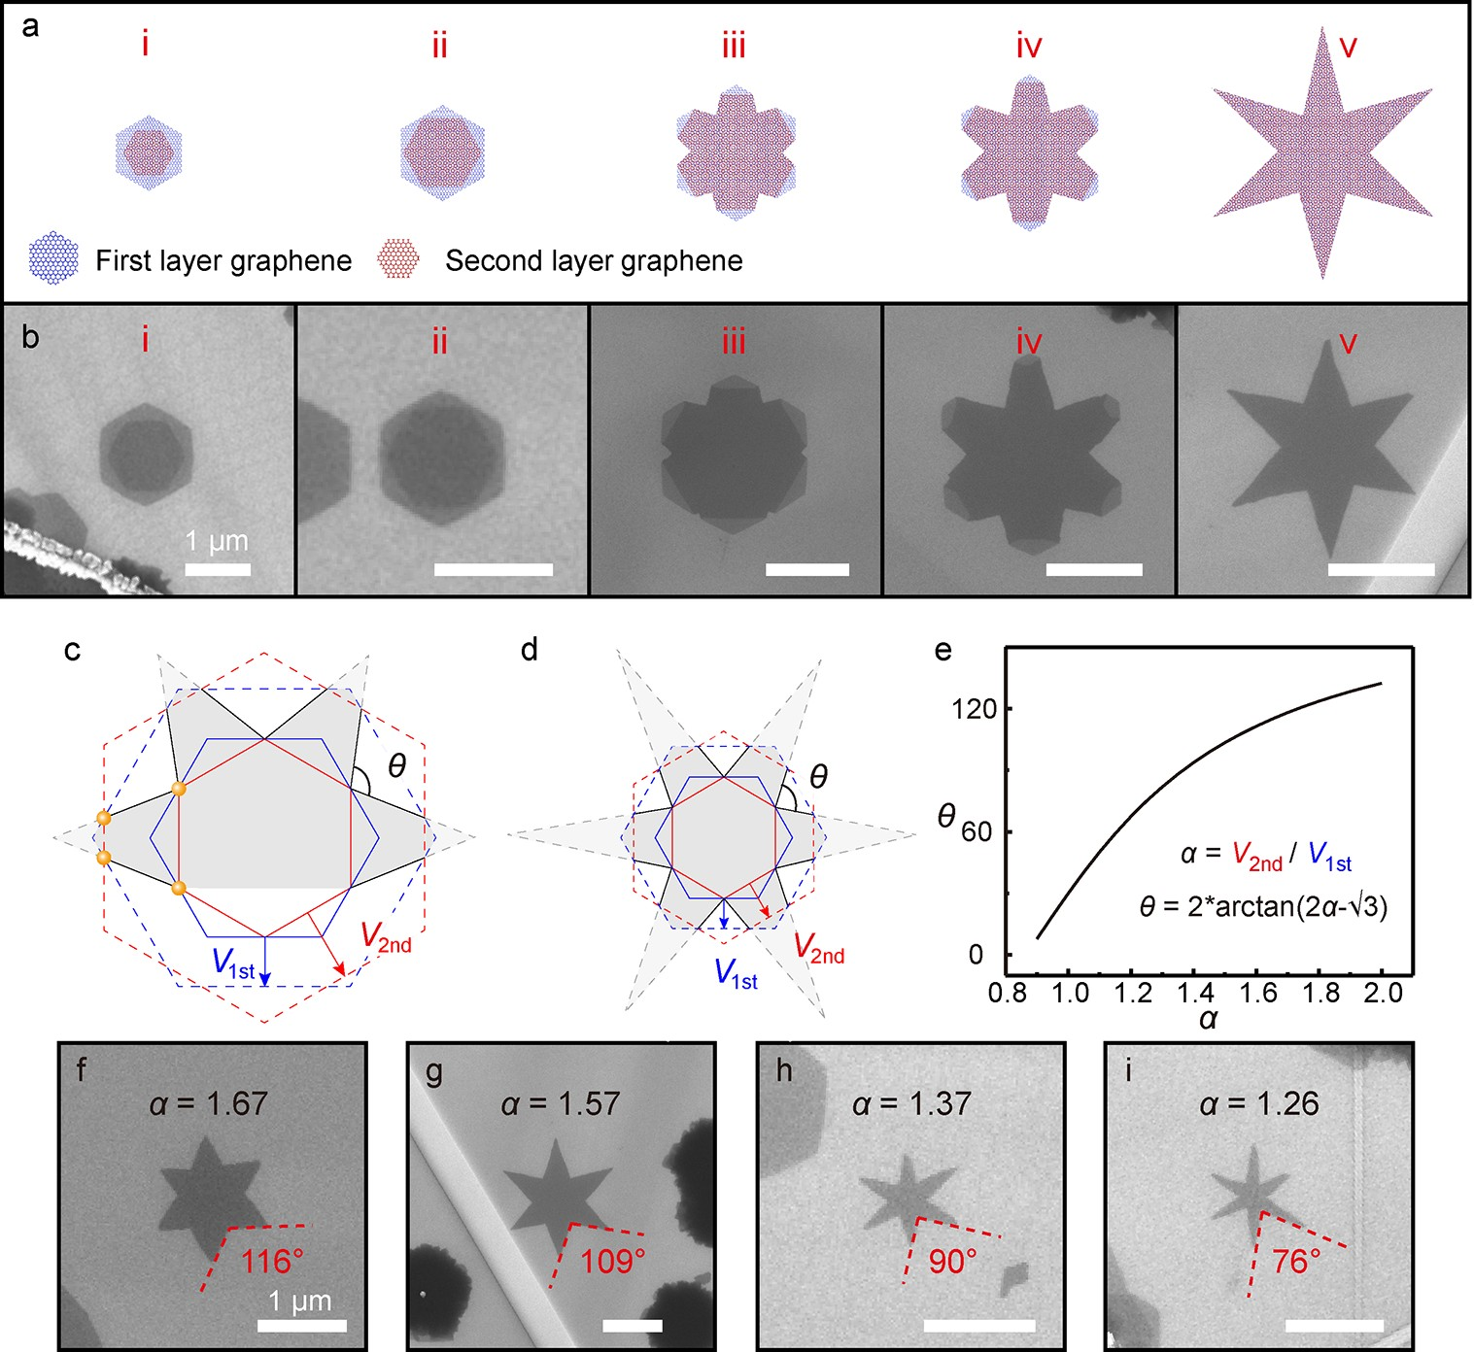

Figure 4. Hexagram bilayer graphene. (a) Schematic of the growth process of hexagram bilayer graphene. (b) SEM results corresponding to the di*ﬀ*erent growth stages shown in panel a. (c, d) Formation processes of hexagram bilayers with di*ﬀ*erent growth speed ratios. Blue and red full-line hexagons represent the *ﬁ*rst and second layers, with their growth speeds designated as *V*first and *V*second, respectively. The growth speed ratios α = *V*second/*V*first are set to be 1.5 and 1.3 for panels c and d, respectively. Blue and red dashed-line hexagons represent the corresponding growth stage,

assuming that the two layers do not form folded edges. Four intersection points of the two layers are marked with orange dots in panel c. Black lines represent the folded edges. The *ﬁ*nal shape of hexagram bilayer graphene is drawn with a gray color. (e) Relation of θ and α. (f−i) SEM results of hexagram bilayers with di*ﬀ*erent shapes. The measured values of θ and the estimated values of α are given in the images.

the schematic diagram (see Figure 4b), therefore validating our proposal for the growth process of hexagram bilayer graphene. The inclined angle of folded edges (θ in Figure 4c,d) is determined by the growth speed ratio of the second and *ﬁ*rst layers, which is de*ﬁ*ned as α = *V*second/*V*first. Here, *V*first and *V*second represent the growing speeds of the *ﬁ*rst and second graphene layers, respectively. In Figures 4c and d, we compare the two examples of hexagram formation, where α values are set to be 1.5 or 1.3, respectively. The full-line hexagons indicate the moment at which the second layer overtakes the *ﬁ*rst layer (equivalently stage ii in Figure 4a). Assuming that folded edges are not formed, two layers will grow to form the dashed-line hexagons later. In reality, the folding appears when the red and blue hexagons begin to intersect. In Figure 4c, the four intersection points of the full-line and dashed-line hexagons are marked with orange dots. The black connection lines of the inside and outside orange dots indicate the gradually formed folded edges. We further discuss the di*ﬀ*erent cases of α: if α is larger, the second layer will catch up more quickly on the *ﬁ*rst layer, thereby forming a larger inclined angle θ. As shown in Figure 4c,d, a relatively obtuse hexagram is obtained, when α is

larger. By geometric operation, the θ−α relation is given as

By tuning the rate of the catalytic silane *ﬂ*ow, we altered the growth speed ratio α. In Figure 4f−i, four typical hexagram graphene bilayers are displayed with gradually varied θ values.

It is noted that a more obtuse hexagram shape indicates a larger α. Using the measured θ, the speed ratios for the various shapes are estimated as 1.67, 1.57, 1.37, and 1.26, respectively. If θ is less than 60°, the outspread folded edges would no longer cross, leading to an “unclosed hexagram” shape ([Figure](http://pubs.acs.org/doi/suppl/10.1021/acs.nanolett.0c04596/suppl_file/nl0c04596_si_001.pdf) [S6](http://pubs.acs.org/doi/suppl/10.1021/acs.nanolett.0c04596/suppl_file/nl0c04596_si_001.pdf)). Apart from the growth speed adjustment, the growth temperature is also an important factor that in*ﬂ*uences the folding process. Our statistical result ([Figure S7](http://pubs.acs.org/doi/suppl/10.1021/acs.nanolett.0c04596/suppl_file/nl0c04596_si_001.pdf)) shows that the ratio of the folded bilayer signi*ﬁ*cantly increases with increasing growth temperature. This may be attributed to the increase in the nucleated probability of the second graphene layer at a higher growth temperature.

Finally, we note that the closed, folded edges observed in our experiment would have some defects. As shown in Figure

4e−i, the angle of folded edges varies, owing to the large-scale variability of α. Therefore, the present folded edges have

di*ﬀ*erent atomic con*ﬁ*gurations. Assuming that such EFBG are unfolded along the folded edge, there will be misaligned orientations between the *ﬁ*rst and second layers in the majority

of cases. A one-dimensional defect line with pentagon−

*θ* = 2 × *arc*tan(2*α* − 3 ): see Figure 4e.

heptagon (5−7) rings is expected to exist along the edge.39,40

Such an intrinsic, topological defect line would markedly alter the electronic transport properties in graphene, for instance, unusual electronic transparency, tunable band gap, zero-energy

states, and room-temperature ferromagnetism.41−44 More

importantly, the defect lines were random with in-plane

polycrystalline graphene but could be designed in our folding growth mode by controlling the growth speed ratio α. As a result, the present folded edges o*ﬀ*er a new platform to explore the novel physics about one-dimensional topological defect lines.

In summary, an entirely new growth mechanism that allows the out-of-plane motion is realized. Such a spontaneous folding growth mode proposes a potential roadmap to achieve designed quasi-3D graphene microstructures by a simple CVD method. The approach presented here allows an easier, more controllable means of folding graphene comparing with other mechanical/chemical methods. Moreover, the tunable, elaborate hexagram constructions o*ﬀ*er ideal platforms for studying the newly emerging physical properties involved in folded edges and topological defect lines. Importantly, this innovative growth mode broadens our prospective horizon for the design of special 3D structures with 2D materials.

# ASSOCIATED CONTENT

*sı Supporting Information

The Supporting Information is available free of charge at [https://pubs.acs.org/doi/10.1021/acs.nanolett.0c04596](https://pubs.acs.org/doi/10.1021/acs.nanolett.0c04596?goto=supporting-info).

CVD growth of graphene, *ﬁ*rst-principles DFT calcu- lations; stacking order of graphene layers on h-BN; θ−α relations for di*ﬀ*erent types of edge folding processes

([PDF](http://pubs.acs.org/doi/suppl/10.1021/acs.nanolett.0c04596/suppl_file/nl0c04596_si_001.pdf))

# AUTHOR INFORMATION

Corresponding [Authors](https://pubs.acs.org/action/doSearch?field1=Contrib&text1=%22Jun-Hyung%2BCho%22&field2=AllField&text2&publication&accessType=allContent&Earliest&ref=pdf)

Jun-Hyung Cho − *Department of Physics, Research Institute for Natural Science, and Institute for High Pressure at Hanyang University, Hanyang University, Seoul 04763, Republic of Korea;* [orcid.org/0000-0002-1785-1835](http://orcid.org/0000-0002-1785-1835); Email: [chojh@hanyang.ac.kr](mailto:chojh@hanyang.ac.kr)

Changgan Zeng − *International Center for Quantum Design of Functional Materials, Hefei National Laboratory for Physical Sciences at the Microscale, CAS Key Laboratory of*

*Strongly Coupled Quantum Matter Physics, Department of Physics, and Synergetic Innovation Center of Quantum Information & Quantum Physics, University of Science and Technology of China, Hefei, Anhui 230026, China;*

[orcid.org/0000-0001-8630-845X](http://orcid.org/0000-0001-8630-845X); Email: [cgzeng@](mailto:cgzeng@ustc.edu.cn) [ustc.edu.cn](mailto:cgzeng@ustc.edu.cn)

[Authors](https://pubs.acs.org/action/doSearch?field1=Contrib&text1=%22Xiaodong%2BFan%22&field2=AllField&text2&publication&accessType=allContent&Earliest&ref=pdf)

Xiaodong Fan − *International Center for Quantum Design of Functional Materials, Hefei National Laboratory for Physical Sciences at the Microscale, CAS Key Laboratory of Strongly Coupled Quantum Matter Physics, Department of Physics, and Synergetic Innovation Center of Quantum Information & Quantum Physics, University of Science and Technology of China, Hefei, Anhui 230026, China*

Sun-Woo Kim − *Department of Physics, Research Institute for*

*Natural Science, and Institute for High Pressure at Hanyang University, Hanyang University, Seoul 04763, Republic of Korea*

Jing Tang − *International Center for Quantum Design of Functional Materials, Hefei National Laboratory for Physical Sciences at the Microscale, CAS Key Laboratory of Strongly Coupled Quantum Matter Physics, Department of Physics, and Synergetic Innovation Center of Quantum Information & Quantum Physics, University of Science and Technology of China, Hefei, Anhui 230026,* [*China*](https://pubs.acs.org/action/doSearch?field1=Contrib&text1=%22Xinjing%2BHuang%22&field2=AllField&text2&publication&accessType=allContent&Earliest&ref=pdf)

Xinjing Huang − *International Center for Quantum Design of Functional Materials, Hefei National Laboratory for Physical*

*Sciences at the Microscale, CAS Key Laboratory of Strongly Coupled Quantum Matter Physics, Department of Physics, and Synergetic Innovation Center of Quantum Information & Quantum Physics, University of Science and Technology of China, Hefei, Anhui 230026,* [*China*](https://pubs.acs.org/action/doSearch?field1=Contrib&text1=%22Zhiyong%2BLin%22&field2=AllField&text2&publication&accessType=allContent&Earliest&ref=pdf)

Zhiyong Lin − *International Center for Quantum Design of*

*Functional Materials, Hefei National Laboratory for Physical Sciences at the Microscale, CAS Key Laboratory of Strongly Coupled Quantum Matter Physics, Department of Physics, and Synergetic Innovation Center of Quantum Information & Quantum Physics, University of Science and Technology of China, Hefei, Anhui 230026,* [*China*](https://pubs.acs.org/action/doSearch?field1=Contrib&text1=%22Lijun%2BZhu%22&field2=AllField&text2&publication&accessType=allContent&Earliest&ref=pdf)

Lijun Zhu − *International Center for Quantum Design of Functional Materials, Hefei National Laboratory for Physical*

*Sciences at the Microscale, CAS Key Laboratory of Strongly Coupled Quantum Matter Physics, Department of Physics, and Synergetic Innovation Center of Quantum Information & Quantum Physics, University of Science and Technology of China, Hefei, Anhui 230026,* [*China*](https://pubs.acs.org/action/doSearch?field1=Contrib&text1=%22Lin%2BLi%22&field2=AllField&text2&publication&accessType=allContent&Earliest&ref=pdf)

Lin Li − *International Center for Quantum Design of*

*Functional Materials, Hefei National Laboratory for Physical Sciences at the Microscale, CAS Key Laboratory of Strongly Coupled Quantum Matter Physics, Department of Physics, and Synergetic Innovation Center of Quantum Information & Quantum Physics, University of Science and Technology of China, Hefei, Anhui 230026, China*

Complete contact information is available at: [https://pubs.acs.org/10.1021/acs.nanolett.0c04596](https://pubs.acs.org/doi/10.1021/acs.nanolett.0c04596?ref=pdf)

Notes

The authors declare no competing *ﬁ*nancial interest.

# ACKNOWLEDGMENTS

This work was supported by the Strategic Priority Research

Program of Chinese Academy of Sciences (XDC07010000), National Natural Science Foundation of China (11974324, 11804326, and U1832151), National Key Research and Development Program of China (2017YFA0403600), Anhui Initiative in Quantum Information Technologies (AHY170000), Hefei Science Center CAS (2018HSC- UE014), and the National Research Foundation of Korea (NRF) grant funded by the Korean Government (2019 R 1A 2C1002975 , 2016 K 1A 4A 3914691, and

2015M3D1A1070609). This work was partially carried out at the USTC Center for Micro and Nanoscale Research and Fabrication.

■

# ABBREVIATIONS

2D, two-dimensional; 3D, three-dimensional; EFBG, edge- folded bilayer graphene; CVD, chemical vapor deposition; SEM, scanning electron microscope; AFM, atomic force microscopy; DFT, density functional theory; MLG, monolayer graphene

# REFERENCES

1. Ebbesen, T. W.; Hiura, H. [Graphene in 3-Dimensions - Towards](https://dx.doi.org/10.1002/adma.19950070618)

[Graphite Origami.](https://dx.doi.org/10.1002/adma.19950070618) *Adv. Mater.* 1995, *7* (6), 582−586.

1. Prada, E.; San-Jose, P.; Brey, L. [Zero Landau level in folded](https://dx.doi.org/10.1103/PhysRevLett.105.106802) [graphene nanoribbons.](https://dx.doi.org/10.1103/PhysRevLett.105.106802) *Phys. Rev. Lett.* 2010, *105* (10), 106802.
2. Zang, J.; Ryu, S.; Pugno, N.; Wang, Q.; Tu, Q.; Buehler, M. J.; Zhao, X. [Multifunctionality and control of the crumpling and](https://dx.doi.org/10.1038/nmat3542) [unfolding of large-area graphene.](https://dx.doi.org/10.1038/nmat3542) *Nat. Mater.* 2013, *12* (4), 321−325.
3. Blees, M. K.; Barnard, A. W.; Rose, P. A.; Roberts, S. P.; McGill,

K. L.; Huang, P. Y.; Ruyack, A. R.; Kevek, J. W.; Kobrin, B.; Muller, D. A.; McEuen, P. L. [Graphene kirigami.](https://dx.doi.org/10.1038/nature14588) *Nature* 2015, *524* (7564), 204− 207.

1. Mu, J.; Hou, C.; Wang, H.; Li, Y.; Zhang, Q.; Zhu, M. [Origami-](https://dx.doi.org/10.1126/sciadv.1500533) [inspired active graphene-based paper for programmable instant self-](https://dx.doi.org/10.1126/sciadv.1500533) [folding walking devices.](https://dx.doi.org/10.1126/sciadv.1500533) *Sci. Adv.* 2015, *1* (10), No. e1500533.
2. Wang, B.; Li, Z.; Wang, C.; Signetti, S.; Cunning, B. V.; Wu, X.; Huang, Y.; Jiang, Y.; Shi, H.; Ryu, S.; Pugno, N. M.; Ruoff, R. S. [Folding Large Graphene-on-Polymer Films Yields Laminated](https://dx.doi.org/10.1002/adma.201707449) [Composites with Enhanced Mechanical Performance.](https://dx.doi.org/10.1002/adma.201707449) *Adv. Mater.* 2018, *30* (35), No. 1707449.
3. Geim, A. K.; Grigorieva, I. V. [Van der Waals heterostructures.](https://dx.doi.org/10.1038/nature12385)

*Nature* 2013, *499* (7459), 419−425.

1. Ponomarenko, L. A.; Gorbachev, R. V.; Yu, G. L.; Elias, D. C.;

Jalil, R.; Patel, A. A.; Mishchenko, A.; Mayorov, A. S.; Woods, C. R.; Wallbank, J. R.; Mucha-Kruczynski, M.; Piot, B. A.; Potemski, M.; Grigorieva, I. V.; Novoselov, K. S.; Guinea, F.; Fal’ko, V. I.; Geim, A.

K. [Cloning of Dirac fermions in graphene superlattices.](https://dx.doi.org/10.1038/nature12187) *Nature* 2013,

*497* (7451), 594−597.

1. Dean, C. R.; Wang, L.; Maher, P.; Forsythe, C.; Ghahari, F.; Gao,

Y.; Katoch, J.; Ishigami, M.; Moon, P.; Koshino, M.; Taniguchi, T.; Watanabe, K.; Shepard, K. L.; Hone, J.; Kim, P. [Hofstadter’s butterfly](https://dx.doi.org/10.1038/nature12186) [and the fractal quantum Hall effect in moire superlattices.](https://dx.doi.org/10.1038/nature12186) *Nature* 2013, *497* (7451), 598−602.

1. Hunt, B.; Sanchez-Yamagishi, J. D.; Young, A. F.; Yankowitz,

M.; LeRoy, B. J.; Watanabe, K.; Taniguchi, T.; Moon, P.; Koshino, M.; Jarillo-Herrero, P.; Ashoori, R. C. [Massive Dirac fermions and](https://dx.doi.org/10.1126/science.1237240) [Hofstadter butterfly in a van der Waals heterostructure.](https://dx.doi.org/10.1126/science.1237240) *Science* 2013,

*340* (6139), 1427−1430.

1. Cao, Y.; Fatemi, V.; Demir, A.; Fang, S.; Tomarken, S. L.; Luo,

J. Y.; Sanchez-Yamagishi, J. D.; Watanabe, K.; Taniguchi, T.; Kaxiras, E.; Ashoori, R. C.; Jarillo-Herrero, P. [Correlated insulator behaviour](https://dx.doi.org/10.1038/nature26154) [at half-filling in magic-angle graphene superlattices.](https://dx.doi.org/10.1038/nature26154) *Nature* 2018, *556*

(7699), 80−84.

1. Cao, Y.; Fatemi, V.; Fang, S.; Watanabe, K.; Taniguchi, T.;

Kaxiras, E.; Jarillo-Herrero, P. [Unconventional superconductivity in](https://dx.doi.org/10.1038/nature26160) [magic-angle graphene superlattices.](https://dx.doi.org/10.1038/nature26160) *Nature* 2018, *556* (7699), 43−50.

1. Seyler, K. L.; Rivera, P.; Yu, H.; Wilson, N. P.; Ray, E. L.;

Mandrus, D. G.; Yan, J.; Yao, W.; Xu, X. [Signatures of moire-trapped](https://dx.doi.org/10.1038/s41586-019-0957-1) [valley excitons in MoSe2/WSe2 heterobilayers.](https://dx.doi.org/10.1038/s41586-019-0957-1) *Nature* 2019, *567* (7746), 66−70.

1. Tran, K.; Moody, G.; Wu, F.; Lu, X.; Choi, J.; Kim, K.; Rai, A.;

Sanchez, D. A.; Quan, J.; Singh, A.; Embley, J.; Zepeda, A.; Campbell, M.; Autry, T.; Taniguchi, T.; Watanabe, K.; Lu, N.; Banerjee, S. K.;

Silverman, K. L.; Kim, S.; Tutuc, E.; Yang, L.; MacDonald, A. H.; Li,

X. [Evidence for moire excitons in van der Waals heterostructures.](https://dx.doi.org/10.1038/s41586-019-0975-z)

*Nature* 2019, *567* (7746), 71−75.

1. Jin, C.; Regan, E. C.; Yan, A.; Iqbal Bakti Utama, M.; Wang, D.;

Zhao, S.; Qin, Y.; Yang, S.; Zheng, Z.; Shi, S.; Watanabe, K.; Taniguchi, T.; Tongay, S.; Zettl, A.; Wang, F. [Observation of moire](https://dx.doi.org/10.1038/s41586-019-0976-y) [excitons in WSe2/WS2 heterostructure superlattices.](https://dx.doi.org/10.1038/s41586-019-0976-y) *Nature* 2019,

*567* (7746), 76−80.

1. Han, E.; Yu, J.; Annevelink, E.; Son, J.; Kang, D. A.; Watanabe,

K.; Taniguchi, T.; Ertekin, E.; Huang, P. Y.; van der Zande, A. M. [Ultrasoft slip-mediated bending in few-layer graphene.](https://dx.doi.org/10.1038/s41563-019-0529-7) *Nat. Mater.* 2020, *19* (3), 305−309.

1. Zheng, Y.; Wei, N.; Fan, Z.; Xu, L.; Huang, Z. [Mechanical](https://dx.doi.org/10.1088/0957-4484/22/47/479501)

[properties of grafold: a demonstration of strengthened graphene.](https://dx.doi.org/10.1088/0957-4484/22/47/479501)

*Nanotechnology* 2011, *22* (47), 479501.

1. Feng, J.; Qi, L.; Huang, J. Y.; Li, J. [Geometric and electronic](https://dx.doi.org/10.1103/PhysRevB.80.165407) [structure of graphene bilayer edges.](https://dx.doi.org/10.1103/PhysRevB.80.165407) *Phys. Rev. B: Condens. Matter Mater. Phys.* 2009, *80* (16), 165407.
2. Park, N.; Yoon, M.; Berber, S.; Ihm, J.; Osawa, E.; Tomanek, D. [Magnetism in all-carbon nanostructures with negative Gaussian](https://dx.doi.org/10.1103/PhysRevLett.91.237204) [curvature.](https://dx.doi.org/10.1103/PhysRevLett.91.237204) *Phys. Rev. Lett.* 2003, *91* (23), 237204.
3. Rainis, D.; Taddei, F.; Polini, M.; León, G.; Guinea, F.; Fal’ko,

V. I. [Gauge fields and interferometry in folded graphene.](https://dx.doi.org/10.1103/PhysRevB.83.165403) *Phys. Rev. B: Condens. Matter Mater. Phys.* 2011, *83* (16), 165403.

1. Chen, X.; Zhang, L.; Zhao, Y.; Wang, X.; Ke, C. [Graphene](https://dx.doi.org/10.1063/1.4898760) [folding on flat substrates.](https://dx.doi.org/10.1063/1.4898760) *J. Appl. Phys.* 2014, *116* (16), 164301.
2. Annett, J.; Cross, G. L. [Self-assembly of graphene ribbons by](https://dx.doi.org/10.1038/nature18304) [spontaneous self-tearing and peeling from a substrate.](https://dx.doi.org/10.1038/nature18304) *Nature* 2016, *535* (7611), 271−275.
3. Zhang, J.; Xiao, J.; Meng, X.; Monroe, C.; Huang, Y.; Zuo, J. M.

[Free folding of suspended graphene sheets by random mechanical](https://dx.doi.org/10.1103/PhysRevLett.104.166805) [stimulation.](https://dx.doi.org/10.1103/PhysRevLett.104.166805) *Phys. Rev. Lett.* 2010, *104* (16), 166805.

1. Hou, T.; Cheng, G.; Tse, W.-K.; Zeng, C.; Qiao, Z. [Topological](https://dx.doi.org/10.1103/PhysRevB.98.245417) [zero-line modes in folded bilayer graphene.](https://dx.doi.org/10.1103/PhysRevB.98.245417) *Phys. Rev. B: Condens. Matter Mater. Phys.* 2018, *98* (24), 245417.
2. Schmidt, H.; Rode, J. C.; Smirnov, D.; Haug, R. J. [Superlattice](https://dx.doi.org/10.1038/ncomms6742) [structures in twisted bilayers of folded graphene.](https://dx.doi.org/10.1038/ncomms6742) *Nat. Commun.* 2014, *5*, 5742.
3. Chen, H.; Zhang, X. L.; Zhang, Y. Y.; Wang, D. F.; Bao, D. L.; Que, Y. D.; Xiao, W. D.; Du, S. X.; Ouyang, M.; Pantelides, S. T.; Gao, H. J. [Atomically precise, custom-design origami graphene](https://dx.doi.org/10.1126/science.aax7864)

[nanostructures.](https://dx.doi.org/10.1126/science.aax7864) *Science* 2019, *365* (6457), 1036−1040.

1. Huang, J. Y.; Ding, F.; Yakobson, B. I.; Lu, P.; Qi, L.; Li, J. [In](https://dx.doi.org/10.1073/pnas.0905193106)

[situ observation of graphene sublimation and multi-layer edge](https://dx.doi.org/10.1073/pnas.0905193106) [reconstructions.](https://dx.doi.org/10.1073/pnas.0905193106) *Proc. Natl. Acad. Sci. U. S. A.* 2009, *106* (25), 10103−10108.

1. Liu, Z.; Suenaga, K.; Harris, P. J.; Iijima, S. [Open and closed](https://dx.doi.org/10.1103/PhysRevLett.102.015501)

[edges of graphene layers.](https://dx.doi.org/10.1103/PhysRevLett.102.015501) *Phys. Rev. Lett.* 2009, *102* (1), 015501.

1. Campos-Delgado, J.; Kim, Y. A.; Hayashi, T.; Morelos-Gómez, A.; Hofmann, M.; Muramatsu, H.; Endo, M.; Terrones, H.; Shull, R. D.; Dresselhaus, M. S.; Terrones, M. [Thermal stability studies of](https://dx.doi.org/10.1016/j.cplett.2008.12.082) [CVD-grown graphene nanoribbons: Defect annealing and loop](https://dx.doi.org/10.1016/j.cplett.2008.12.082)

[formation.](https://dx.doi.org/10.1016/j.cplett.2008.12.082) *Chem. Phys. Lett.* 2009, *469* (1−3), 177−182.

1. Jian, K.; Yan, A.; Külaots, I.; Crawford, G. P.; Hurt, R. H.

[Reconstruction and hydrophobicity of nanocarbon surfaces composed](https://dx.doi.org/10.1016/j.carbon.2006.03.035) [solely of graphene edges.](https://dx.doi.org/10.1016/j.carbon.2006.03.035) *Carbon* 2006, *44* (10), 2102−2106.

1. Zhu, S. Z.; Li, T. [Hydrogenation-Assisted Graphene Origami](https://dx.doi.org/10.1021/nn500025t)

[and Its Application in Programmable Molecular Mass Uptake,](https://dx.doi.org/10.1021/nn500025t) [Storage, and Release.](https://dx.doi.org/10.1021/nn500025t) *ACS Nano* 2014, *8* (3), 2864−2872.

1. Xu, W. A.; Qin, Z.; Chen, C. T.; Kwag, H. R.; Ma, Q. L.; Sarkar,

A.; Buehler, M. J.; Gracias, D. H. [Ultrathin thermoresponsive self-](https://dx.doi.org/10.1126/sciadv.1701084) [folding 3D graphene.](https://dx.doi.org/10.1126/sciadv.1701084) *Sci. Adv.* 2017, *3* (10), No. e1701084.

1. Tang, S.; Wang, H.; Wang, H. S.; Sun, Q.; Zhang, X.; Cong, C.; Xie, H.; Liu, X.; Zhou, X.; Huang, F.; Chen, X.; Yu, T.; Ding, F.; Xie, X.; Jiang, M. [Silane-catalysed fast growth of large single-crystalline](https://dx.doi.org/10.1038/ncomms7499) [graphene on hexagonal boron nitride.](https://dx.doi.org/10.1038/ncomms7499) *Nat. Commun.* 2015, *6*, 6499.
2. Yang, W.; Chen, G.; Shi, Z.; Liu, C. C.; Zhang, L.; Xie, G.; Cheng, M.; Wang, D.; Yang, R.; Shi, D.; Watanabe, K.; Taniguchi, T.;

Yao, Y.; Zhang, Y.; Zhang, G. [Epitaxial growth of single-domain](https://dx.doi.org/10.1038/nmat3695) [graphene on hexagonal boron nitride.](https://dx.doi.org/10.1038/nmat3695) *Nat. Mater.* 2013, *12* (9), 792−

797.

1. Nie, S.; Wu, W.; Xing, S. R.; Yu, Q. K.; Bao, J. M.; Pei, S. S.; McCarty, K. F. [Growth from below: bilayer graphene on copper by](https://dx.doi.org/10.1088/1367-2630/14/9/093028) [chemical vapor deposition.](https://dx.doi.org/10.1088/1367-2630/14/9/093028) *New J. Phys.* 2012, *14*, 093028.
2. Yan, Z.; Peng, Z.; Tour, J. M. [Chemical vapor deposition of](https://dx.doi.org/10.1021/ar4003043) [graphene single crystals.](https://dx.doi.org/10.1021/ar4003043) *Acc. Chem. Res.* 2014, *47* (4), 1327−1337.
3. Xu, X.; Zhang, Z.; Dong, J.; Yi, D.; Niu, J.; Wu, M.; Lin, L.; Yin,

R.; Li, M.; Zhou, J.; Wang, S.; Sun, J.; Duan, X.; Gao, P.; Jiang, Y.;

Wu, X.; Peng, H.; Ruoff, R. S.; Liu, Z.; Yu, D.; Wang, E.; Ding, F.; Liu,

K. [Ultrafast epitaxial growth of metre-sized single-crystal graphene on](https://dx.doi.org/10.1016/j.scib.2017.07.005) [industrial Cu foil.](https://dx.doi.org/10.1016/j.scib.2017.07.005) *Sci. Bull.* 2017, *62* (15), 1074−1080.

1. Su, N.; Liu, M.; Liu, F. [Chemical versus thermal folding of](https://dx.doi.org/10.1007/s12274-011-0175-0) [graphene edges.](https://dx.doi.org/10.1007/s12274-011-0175-0) *Nano Res.* 2011, *4* (12), 1242−1247.
2. Yazyev, O. V.; Louie, S. G. [Topological defects in graphene:](https://dx.doi.org/10.1103/PhysRevB.81.195420) [Dislocations and grain boundaries.](https://dx.doi.org/10.1103/PhysRevB.81.195420) *Phys. Rev. B: Condens. Matter Mater. Phys.* 2010, *81* (19), 195420.
3. Huang, P. Y.; Ruiz-Vargas, C. S.; van der Zande, A. M.; Whitney, W. S.; Levendorf, M. P.; Kevek, J. W.; Garg, S.; Alden, J. S.; Hustedt, C. J.; Zhu, Y.; Park, J.; McEuen, P. L.; Muller, D. A. [Grains](https://dx.doi.org/10.1038/nature09718)

[and grain boundaries in single-layer graphene atomic patchwork](https://dx.doi.org/10.1038/nature09718) [quilts.](https://dx.doi.org/10.1038/nature09718) *Nature* 2011, *469* (7330), 389−392.

1. Miller, D. L.; Kubista, K. D.; Rutter, G. M.; Ruan, M.; de Heer,

W. A.; First, P. N.; Stroscio, J. A. [Observing the Quantization of Zero](https://dx.doi.org/10.1126/science.1171810) [Mass Carriers in Graphene.](https://dx.doi.org/10.1126/science.1171810) *Science* 2009, *324* (5929), 924−927.

1. Červenka, J.; Katsnelson, M. I.; Flipse, C. F. J. [Room-](https://dx.doi.org/10.1038/nphys1399)

[temperature ferromagnetism in graphite driven by two-dimensional](https://dx.doi.org/10.1038/nphys1399) [networks of point defects.](https://dx.doi.org/10.1038/nphys1399) *Nat. Phys.* 2009, *5* (11), 840−844.

1. Yazyev, O. V.; Louie, S. G. [Electronic transport in](https://dx.doi.org/10.1038/nmat2830) [polycrystalline graphene.](https://dx.doi.org/10.1038/nmat2830) *Nat. Mater.* 2010, *9* (10), 806−809.
2. Tsen, A. W.; Brown, L.; Levendorf, M. P.; Ghahari, F.; Huang,

P. Y.; Havener, R. W.; Ruiz-Vargas, C. S.; Muller, D. A.; Kim, P.; Park,

J. [Tailoring Electrical Transport Across Grain Boundaries in](https://dx.doi.org/10.1126/science.1218948) [Polycrystalline Graphene.](https://dx.doi.org/10.1126/science.1218948) *Science* 2012, *336* (6085), 1143−1146.